1. Set memory (SGA/PGA)
ALTER SYSTEM SET SGA_TARGET = 1G SCOPE = SPFILE;
ALTER SYSTEM SET PGA_AGGREGATE_TARGET = 512M SCOPE = SPFILE;
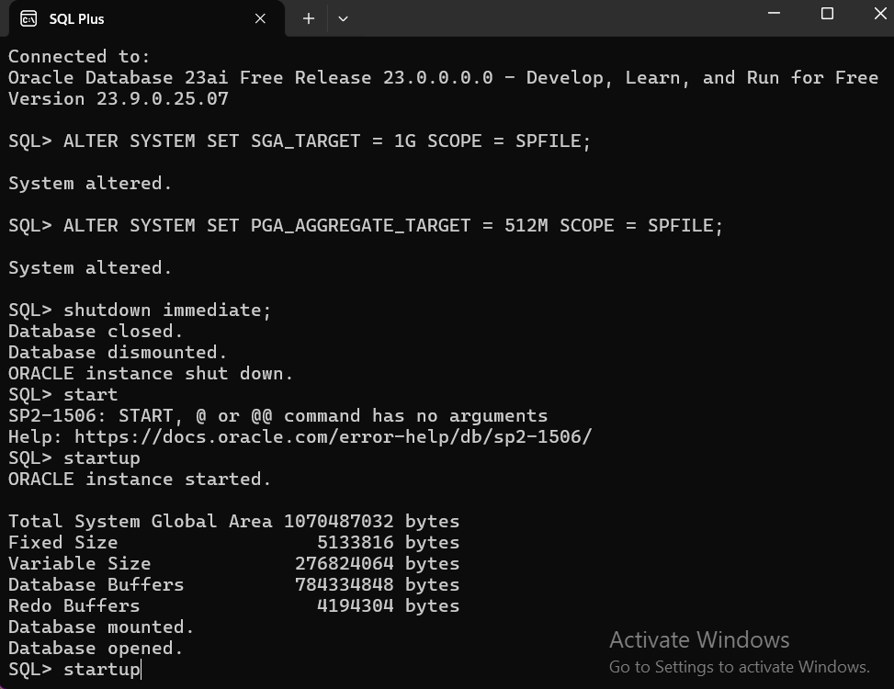

- Create the PDB
CREATE PLUGGABLE DATABASE D_28204_Divine_USHBRIDGE_DB
ADMIN USER divine_admin IDENTIFIED BY Divine
FILE_NAME_CONVERT = (
'C:\app\oradata\FREE\pdbseed',
'C:\app\oradata\FREE\D_28204_Divine_USHBRIDGE_DB'
);

- Open the PDB
ALTER PLUGGABLE DATABASE D_28204_Divine_USHBRIDGE_DB OPEN READ WRITE;
SHOW PDBS;
- Create tablespaces
Table space
CREATE TABLESPACE data_ts
DATAFILE 'C:\app\oradata\FREE\D_28204_Divine_USHBRIDGE_DB\data01.dbf'
SIZE 500M
AUTOEXTEND ON NEXT 50M MAXSIZE UNLIMITED;
Index table
CREATE TABLESPACE index_ts
DATAFILE 'C:\app\oradata\FREE\D_28204_Divine_USHBRIDGE_DB\index01.dbf'
SIZE 300M
AUTOEXTEND ON NEXT 50M MAXSIZE UNLIMITED;
Extending temporary table
ALTER DATABASE TEMPFILE 'C:\app\oradata\FREE\D_28204_Divine_USHBRIDGE_DB\temp01.dbf'
AUTOEXTEND ON NEXT 50M MAXSIZE UNLIMITED;

- Create your admin user
Unlocking the grants
ALTER USER divine_admin IDENTIFIED BY "Divine" ACCOUNT UNLOCK;
GRANT CREATE SESSION TO divine_admin;
GRANT CONNECT, RESOURCE, DBA TO divine_admin;
GRANT UNLIMITED TABLESPACE TO divine_admin;
Giving the tables quotas
ALTER USER divine_admin QUOTA UNLIMITED ON data_ts;
ALTER USER divine_admin QUOTA UNLIMITED ON index_ts;
Testing
